PROJECT REPORT FOR BACHELOR OF COMPUTER SCIENCE AND INFORMATION TECHNOLOGY

**SPRINGBALL**



A project report submitted for First Semester C Programming Project of Bachelor of Computer Science and Technology

**Binisha Naga [26798]**

**Deepika Sainju [26800]**

**Krima Madhikarmi [26803]**

**Usha Suwal [26839]**

**SAMRIDDHI COLLEGE**

**DEPARTMENT OF SCIENCE AND TECHNOLOGY**

**Jan,2022**

PROJECT REPORT FOR BACHELOR OF COMPUTER SCIENCE AND INFORMATION TECHNOLOGY

**SPRINGBALL**

**SUPERVISED BY**

Mohan Bhandari

FACULTY, SAMRIDDHI COLLEGE

A REPORT SUBMITTED

FOR

FIRST SEMESTER C-PROJECT

**Binisha Naga [26798]**

**Deepika Sainju [26800]**

**Krima Madhikarmi [26803]**

**Usha Suwal [26839]**

**SAMRIDDHI COLLEGE**

**DEPARTMENT OF SCIENCE AND TECHNOLOGY**

**Jan, 2022**

# DECLARATION

We hereby declare that this project entitled **SPRINGBALL** is based on my original research work. Related works on this project by other researchers have been duly acknowledged. We owe all the liabilities relating to the accuracy and authenticity of the data and any other information included hereunder.

………………………… ………………………...

Deepika Sainju [26800] Binisha Naga [26798]

………………………… ….………………………...

Usha Suwal [26839] Krima Madhikarmi [26803]

Date: 2022-01-28

**RECOMMENDATION**

This is to certify that this project entitled **SPRINGBALL** prepared and submitted by **Deepika Sainju, Binisha Naga, Usha Suwal** and **Krima Madhikarmi** for First Semester C Project of Bachelor of Computer Science and Information Technology awarded by Tribhuvan University, has been completed under my supervision.

……………………..

**Mohan Bhandari**

Faculty: Samriddhi College

Date: January, 2022

# ACKNOWLEDGMENT

We are very thankful to Samridhi College for provision of expertise, and support in the implementation. Without their superior knowledge, the project would like in quality of outcomes, and thus their support has been essential.

We would like to express our sincere thanks toward our faculty members of C-Programming Mr. Mohan Bhandari and Mr. Jeeban Dhungel who help us for the encouragement and motivation for this project, and Mr. Gaurab Suwal and again Mr. Mohan Bhandari for their supervision and support. We would also like to thank our principal Mr. Sandeep Shrestha along with Mr. Arpan Maskey for providing environment and facilities due to which we were able to develop this project successfully. Also we would like to thank our seniors for enlightening great help and suggestions for this project through their presentation.

Nevertheless, we express our gratitude toward our families and colleagues for their kind co-operation and encouragement, which help us in completion of this project.

# ABSTRACT

Springball is a simple game in which a ball jumps its way through the various obstacles scoring a point each time it passes a obstacle. The games ends when the ball touches or strikes any obstacle and the obtained score is shown. Hence, it is a game that can be developed using graphics library.

Our project, Springball, not only aims to widen our knowledge but also showcase our skills and in C- Programming language along with Graphics Library, and it also provides entertainment to the people who play our game.

For this project, Springball, we took reference from the popular game Flappy Bird. Flappy bird in its initial form was an android game developed by Dong Nguyen under his game development company dotGears.

Keywords: **Springball, C- program Graphics, Obstacle, Bird Game**

# TABLE OF CONTENT

1. INTRODUCTION 1

1.1 INTRODUCTION 1

1.2 PROBLEM STATEMENT 1

1.3 OBJECTIVES 1

1.4 SCOPE 2

1.5 OVERVIEW OF REPORT 2

2. BACKGROUND STUDY AND LITERATURE REVIEW 3

2.1 BACKGROUND STUDY 3

2.2 LITERATURE REVIEW 4

3. SYSTEM ANALYSIS AND DESIGN 5

3.1 SYSTEM ANALYSIS 5

3.1.1 REQUIREMENT ANALYSIS 5

3.1.2 FEASIBILITY ANALYSIS 6

3.2 SYSTEM DESIGN 7

3.2.1 ALGORITHM 7

3.2.2 FLOWCHART 8

4. RESULT AND DISCUSSION 9

4.1 RESULT 9

4.2 TEST CASES 14

5. LIMITATION 18

6. FUTURE WORK 19

7. RECOMMENDATION AND CONCLUSION 20

7.1 RECOMMENDATION 20

7.2 CONCLUSION 20

REFERENCE 21

# LIST OF FIGURES

Figure 1: Flowchart of the project 8

Figure 2: Screenshot of Main menu 9

Figure 3:Screenshot of Instruction screen 10

Figure 4:Screenshot of Game play 11

Figure 5:Screenshot of Game over 12

Figure 6:Screenshot of View score screen 13

# LIST OF TABLES

Table 1:Test case 1 14

Table 2:Test case 2 14

Table 3: Test case 3 15

Table 4: Test case 4 15

Table 5: Test case 5 16

Table 6: Test case 6 16

Table 7: Test case 7 17

# LIST OF ABBREVIATIONS

|  |  |
| --- | --- |
| 2D | Two Dimensional |
| EXEC | Executable |
| PCs | Personal Computers |
|  |  |

# 1. INTRODUCTION

## 1.1 INTRODUCTION

SpringBall is a 2D reference game of the popular Flappy Bird game. It is a fun game that use concept of endless obstacles to make people to try to beat their own high scores which makes the game fun even when it is repetitive.

This game has a very clear objective to avoid obstacle thus, this is very simple to take up and start playing without hassle. This game is very likeable by children. This is the best way to beat the boredom in the absence of internet. It is very frustrating when we can’t beat the high score easily as the ball keeps striking the obstacle.

This game can be developed by using various C compiler like Dev C, Turbo C etc.

## 1.2 PROBLEM STATEMENT

In this hectic day to day lives of people, they are only thinking of chasing after something to make their accomplishment successful. So, people forget to take break from their hectic lives which causes too much stress and mental issues. Also, due to the corona outbreak and lockdowns, people cannot enjoy outdoor activities and have to cure their boredom through online activities which led people to feel frustrated and bored from all these online stuffs and are in need of some kind of refreshment. And also due to this daily online engagement, children started to explore explicit or bad websites which affect their innocent mentality negatively.

Thus, we are trying to make an easy and traditional referenced game that can take people’s mind off their hectic schedules and give themselves a break with refreshing excitement which our game satisfies. Our game is most likely to attract children which this fun and simple game will have no bad influence and the adults can also refresh their childhood game memories.

## 1.3 OBJECTIVES

The objective of our project are as follows:

1. To utilize our knowledge and skills in CP language into something useful.
2. To provide people with source of good clean fun that will ease their stress.

## 1.4 SCOPE

Our game is EXEC in all PCs which have C compliers like Dev C++, Turbo etc. along with graphics library function.

## 1.5 OVERVIEW OF REPORT

This report consists of seven chapters. The ‘Introduction’ consists of some of the simple details about our Springball and ‘Background Study and Literature Review’ consists of background and some literature related our game. ’Result and Discussion’ consists of discussion about result of our game. The other chapters are Limitation, Future Work, Recommendation and Conclusion. All the chapters consists of required materials about our game in detail.

# 2. BACKGROUND STUDY AND LITERATURE REVIEW

## 2.1 BACKGROUND STUDY

We are also starting out with very beginner level knowledge of CP Language. Thus, we wanted our project to be moderately challenging without hopeless levels of difficulty that would put us off CP Language. It is important to have familiarity with the game so that we ourselves can convince people that our game can satisfy the desired entertainment that they are looking for.

Secondly, we wanted to create a game having the same characteristics as Flappy Bird so that we can enhance our skills and knowledge and gain some extra experience about CP and game developing. We also wanted to try challenge ourselves to enter and overcome small barriers of world of game developing. Having experience about the game development will make it easier to convince people about our capabilities in this field later in the future.

Lastly, we used CP graphics library to attract more players into enjoying this 2D game. And it enabled us to make our game visually more appealing due to the smooth movements and colorful gameplay.

Hence, we decided to develop this game as our project.

## 2.2 LITERATURE REVIEW

C graphics using graphics.h functions or WinBGIM (Windows 7) can be used to draw different shapes, display text in different fonts, change [colors](https://www.programmingsimplified.com/c/graphics.h/colors) and many more. Using functions of graphics.h in Turbo C compiler you can make graphics programs, animations, projects, and games. You can draw circles, lines, rectangles, bars and many other geometrical figures. You can change their colors using the available functions and fill them. [1]

So far the operations using C program are done on a prompt / terminal which is not stored anywhere. But in the software industry, most of the programs are written to store the infomation fetched from the program. One such way is to store the fetched information in a file. Different operations that can be performed on a file are: Creation of a new file (fopen with attributes as “a” or “a+” or “w” or “w++”), Opening an existing file (fopen), Reading from file (fscanf or fgets), Writing to a file (fprintf or fputs), Moving to a specific location in a file (fseek, rewind) and Closing a file (fclose). [2]

In game design, and especially in academia, the concept of [flow](http://en.wikipedia.org/wiki/Flow_(psychology) is a popular theory, established by Hungarian psychology professor [Mihaly Csikszentmihalyi](http://en.wikipedia.org/wiki/Mihaly_Csikszentmihalyi), used to describe optimal gameplay experiences. Flow represents a mental state in which a person becomes so engrossed in a certain activity that enjoyment comes intrinsically from the process of doing that activity. Video games are often built with the goal of providing a positive experience so that playing them becomes intrinsically rewarding, which is basically synonymous with the flow experience. [3]

# 3. SYSTEM ANALYSIS AND DESIGN

## 3.1 SYSTEM ANALYSIS

### 3.1.1 REQUIREMENT ANALYSIS

#### i. FUNCTIONAL REQUIREMENT

There are 4 elements in our project. It includes ball, bar, score manager and game controller. The main objective of the game is to get rid of obstacles by jumping, moving forward, falling downward and die when it strike to obstacle bar.

The major objective of the bar is to collide with the ball while the score manager keeps the track of score when the ball moves past the obstacles.

Some of the major entities of our game are:

1. Main Menu- It displays option like start game, view score, and exit.
2. Start Game – It initialize the game and display instructions about how to play the game.
3. Obstacles- It shows bar obstacle that the player has to avoid.
4. Collide with ball- It detect the collision between ball and obstacles.
5. Game over- It ends the game when a collision is detected.
6. Calculate score- It calculate the score of the player.

#### ii. NON-FUNCTIONAL REQUIREMENT

#### a. ACCESSIBILITY

Our game can only be accessed if one has the file and graphics.h library settings in their PCs. It is not easily portable.

#### b. PERFORMANCE

In this game, jumping of the ball and continuous formation of the bar is untroubled and the score obtained is also displayed after the game ends. Our game glitches a bit because graphics.h is not supported so well.

#### c. APPEARANCE

Spring ball might give you vibes similar to the popular game flappy bird since it has bar in place of pipe and ball instead of bird. This makes Spring ball looks a bit similar to the flappy bird. We also added a dot in the ball to make it look as if it has a eye.

## 3.1.2 FEASIBILITY ANALYSIS

#### i. TECHNICAL FEASIBILITY

Our project is technically feasible because the code is written in C so it doesn’t require much investment except to learn Graphics in C which is easy to learn.

#### ii. OPERATIONAL FEASIBILITY

Our project is operationally feasible since no investment is required to run it, normally it only requires one to have the file and graphics setting in their PC.

#### iii. ECONOMIC FEASIBILITY

Our game doesn’t require any cost to develop, run and to play. So it is economically feasible to anyone who is interested in our game.

#### iv. SCHEDULE FEASIBILITY

It is feasible in any schedule because it only required a week to program. It doesn’t require much time investment.

## 3.2 SYSTEM DESIGN

### 3.2.1 ALGORITHM

STEP 1: Start

STEP 2: Display menu

STEP 3: Choose 1 to start game, 2 to view score and 3 to exit and store in choice.

STEP 4: If choice = 1, display instruction window.

Else if choice=2, display view score window

Else if choice=3, goto step 8.

Else goto step 2.

STEP 5: Enter any key to run the game.

STEP 6: If ball collide, display Game Over and score.

STEP 7: Goto step 2.

STEP 8: Exit

## 3.2.2 FLOWCHART

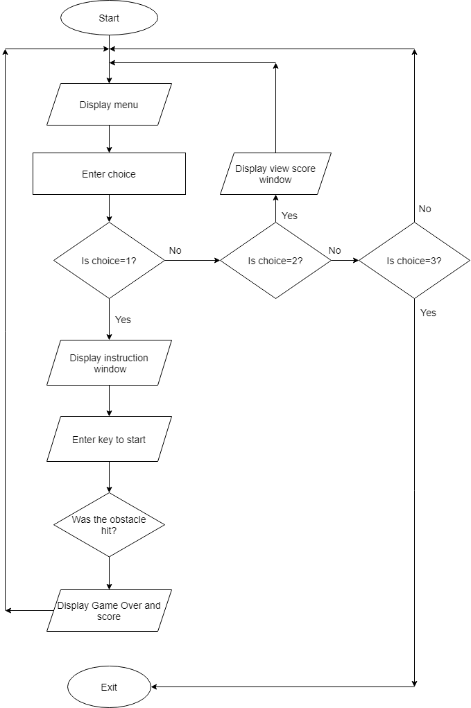

Figure 1: Flowchart of the project

# 4. RESULT AND DISCUSSION

## 4.1 RESULT

The final output of our project has following outputs: 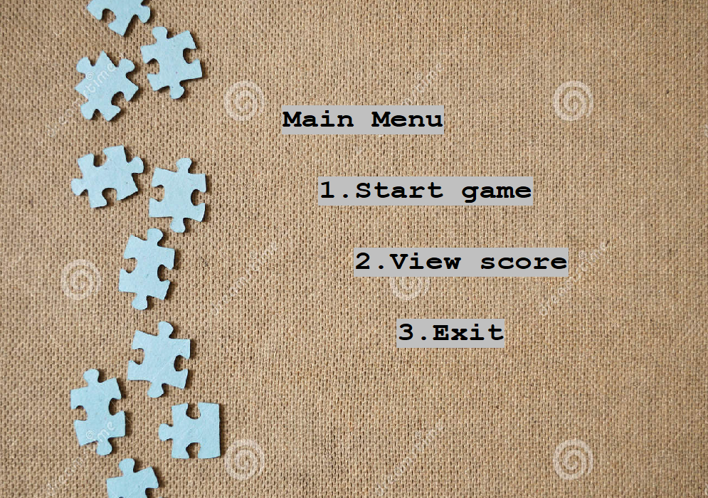

Figure 2: Screenshot of Main menu

The code we wrote was successful to produce the desired menu screen. We included options like start game, view score and exit in this main menu. We also inserted background image to make main menu more attractive. The objective of included option are as follows:

1. Start game: Instruction menu is displayed and after that the player can start playing the game.
2. View score: It displays the highest score.
3. Exit: It exit the game.

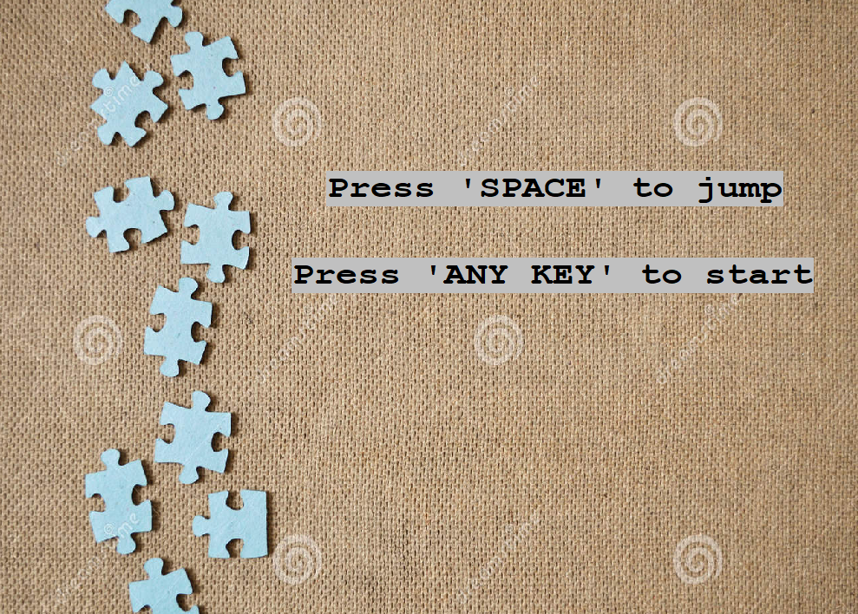These are the instruction displayed to show the control of the game to the player. This makes it easier for the player to understand the function of game before playing.

Figure 3:Screenshot of Instruction screen

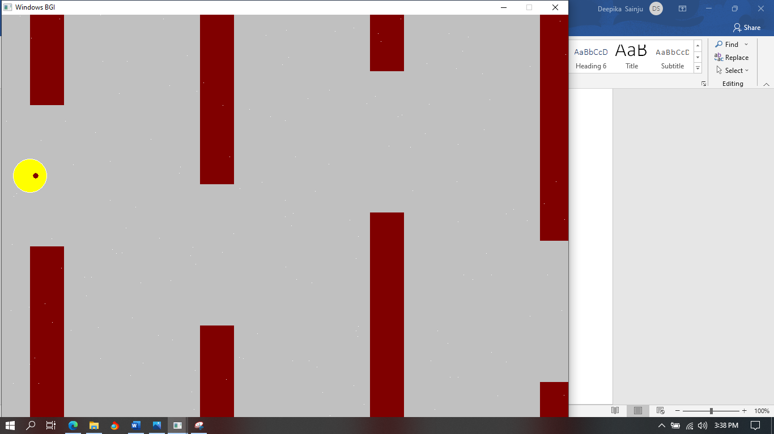

Figure 4:Screenshot of Game play

This is appearance of the game screen that player see while playing the game. As we can see in figure, the game is centered on the ball moving and avoiding the bar obstacles. The player has to press space key in order to make the ball jump so that it can avoid the obstacle bar and gain a score point.

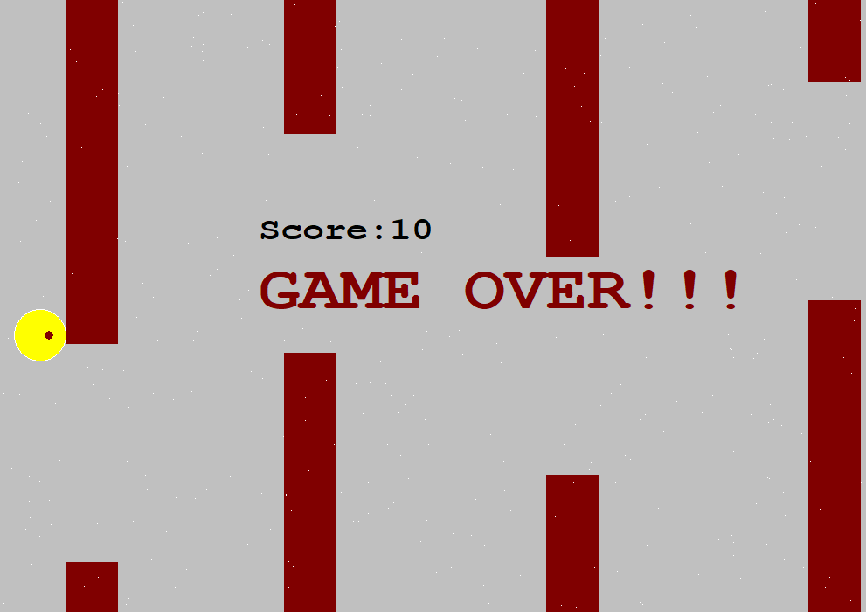

Figure 5:Screenshot of Game over

This screen is shown after a ball strike any obstacles. This means player lost the game. And the obtained score is displayed with a “GAME OVER” text.

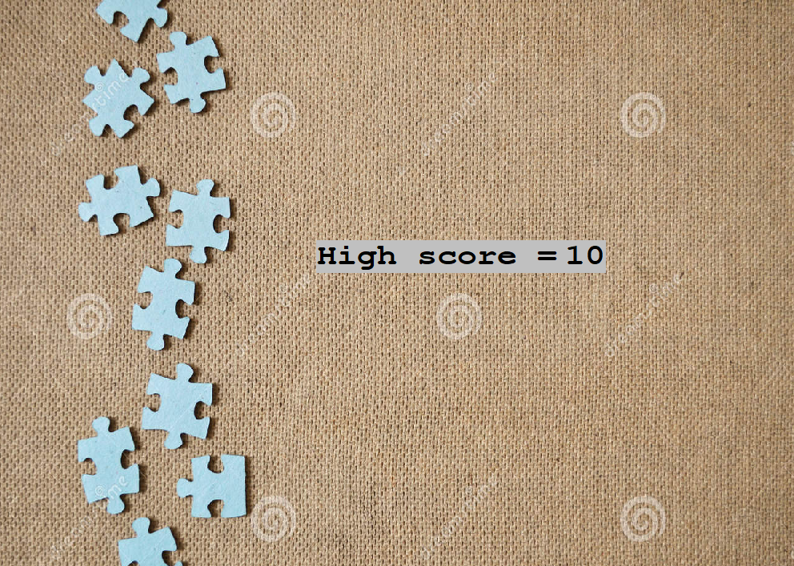This screen is displayed if view score option is selected from the main menu. If the player scores a new high score then the high score is updated.

Figure 6:Screenshot of View score screen

## 4.2 TEST CASES

Table 1:Test case 1

|  |  |  |  |
| --- | --- | --- | --- |
| Test Case ID | TEST_001 | | |
| Test case description | Showing front screen before starting the game. | | |
| Pre requisites | a. C compiler  b. Graphics.h library | | |
| Test scenario | On opening EXEC file | | |
| Test data | Desired Screen Size (1000 x 800) | | |
| Steps | Expected Result | Actual Result | Pass/Fail |
| a. Open EXEC file.  b. Provide desired screen size | Front screen should be shown | Front screen was shown | Pass |

Table 2:Test case 2

|  |  |  |  |
| --- | --- | --- | --- |
| Test Case ID | TEST_002 | | |
| Test case description | Showing main menu after front screen and before starting game | | |
| Pre requisites | Running instance of the game. | | |
| Test scenario | After showing front screen. | | |
| Test data |  | | |
| Steps | Expected Result | Actual Result | Pass/Fail |
| Run EXEC file. | Main menu should be shown | Main menu was shown | Pass |

Table 3: Test case 3

|  |  |  |  |
| --- | --- | --- | --- |
| Test Case ID | TEST_003 | | |
| Test case description | Showing main menu after starting the game. | | |
| Pre requisites | Running instance of the game. | | |
| Test scenario | On ending the game | | |
| Test data |  | | |
| Steps | Expected Result | Actual Result | Pass/Fail |
| a. Move the ball.  b. Collide with the obstacles. | Main menu should be shown | Main menu was shown | Pass |

Table 4: Test case 4

|  |  |  |  |
| --- | --- | --- | --- |
| Test Case ID | TEST_004 | | |
| Test case description | Selection of menu options. | | |
| Pre requisites | a. C complier  b. User interface. | | |
| Test scenario | On key press of numeric key. | | |
| Test data | Numeric key (1/2/3). | | |
| Steps | Expected Result | Actual Result | Pass/Fail |
| a. Press<Numeric Key> | Options should be selected | Options were selected | Pass |

Table 5: Test case 5

|  |  |  |  |
| --- | --- | --- | --- |
| Test Case ID | TEST_005 | | |
| Test case description | Movement on key press of space key only. | | |
| Pre requisites | a. C complier  b. User interface.  c. kbhit( ) function. | | |
| Test scenario | On key press of space key. | | |
| Test data | Space key. | | |
| Steps | Expected Result | Actual Result | Pass/Fail |
| a. Run the game.  b. Start the game.  c. Press<Space key> | Ball should move. | Ball moved | Pass |

Table 6: Test case 6

|  |  |  |  |
| --- | --- | --- | --- |
| Test Case ID | TEST_006 | | |
| Test case description | Displaying obtained score after ending the game. | | |
| Pre requisites | a. C complier  b. File handling | | |
| Test scenario | After ball hit obstacles. | | |
| Test data |  | | |
| Steps | Expected Result | Actual Result | Pass/Fail |
| a. Start the game.  b. Hit the obstacle. | Score should be displayed | Score was displayed | Pass |

Table 7: Test case 7

|  |  |  |  |
| --- | --- | --- | --- |
| Test Case ID | TEST_007 | | |
| Test case description | High score check after ending the game. | | |
| Pre requisites | a. C complier  b. File handling. | | |
| Test scenario | On selection of “View score” option. | | |
| Test data | On key press of numeric key. | | |
| Steps | Expected Result | Actual Result | Pass/Fail |
| a. Press<Numeric Key(2)> | The new high score should be recorded in high score. | The new high score was recorded in high score | Pass |

# 5. LIMITATION

While developing this game we faced various confusing problems, among which some are solved and some of them are difficult to overcome. The problem of the image not supporting in C graphics was solved after we installed graphics properly. Various limitation of our game are:

1. Game glitching: When the Gameplay screen is running, it keeps glitching in some time interval because graphics in C is not supported properly. But overall the gameplay is smooth and enjoyable.
2. Striking problem: The collision between the ball and bar obstacle is not detected properly. In some cases the collision between edges of ball and bar is detected but in some cases the collision between center of ball and edge of bar is detected. This problem has not been solved.
3. Real time score: We were not able to show increasing real time score point while playing game. The total obtained score is shown after game ends.
4. Background image unsupportive: We tried to insert background image while playing the game, but it was not supported which resulted in intense glitching of the game screen.

Hence these are the limitation that we faced while developing this game.

# 6. FUTURE WORK

After working with Springball, we have come to understand CP, Graphics and game development. Some of the features that we desired to add in this game are:

1. Better design of the ball: To make this game more appealing to the player, the ball can have modified designs or we can use other object like bird, ufo, octopus, etc.
2. Extra special point: We can add some special point gaining material such as coin, booster, etc to make game more fun and interesting. If we gain some coins we can purchase some customs for the ball and if we gain booster we can increase the speed and avoid hitting the obstcales for short period of time.
3. Real time score: We can insert real time score point counting in gameplay screen. It makes the player feel the urge to keep playing and beat the high score as it can show increase in the score as it get past a obstacle.

# 7. RECOMMENDATION AND CONCLUSION

## 7.1 RECOMMENDATION

For those who would like to take our project as a reference for their work, these are the recommendations that we would like to provide:

First recommendation: There are possibilities of this game development not only on Dev C compiler but also on other compiler like VScode, Turbo C++, Code Blocks etc. You can use any of these compilers as you see fit that would meet your requirement for developing this game. As some of the compiler may not be able to support graphics library properly so you may face some difficulties.

Second recommendation: Be aware of what you can do vs your expectation in game development. When we started this project, we had expectations about making this game perfectly with better design. But it was difficult to insert images as background in gameplay. We initially wanted to insert bird or spaceship but it was difficult to control the movements of the objects and it was also difficult to detect collision between ball and the obstacles. We also wanted to add real time score display.

In conclusion, you can seek help from professionals in case you face any difficulties during game development.

## 7.2 CONCLUSION

Those who want to work on game development in C programming have to work very hard in order to make the movements, appearance and score counting. It was difficult for us to work in C graphics with the knowledge we have.

It was an interesting and delightful project to work on. We learned various extra experiences in game development and C graphics. We had to get some help from professional people to overcome the difficulties that we faced. It was frustrating when a problem came and was exciting when a problem was solved. We enjoyed all the time that we invested for this project.

# REFERENCE

|  |  |
| --- | --- |
| [1] | "Programming Simplified," [Online]. Available: <https://www.programmingsimplified.com>. [Accessed 25 Janurary 2022]. |
| [2] | "GeeksforGeeks," [Online]. Available: <https://www.geeksforgeeks.org>. [Accessed 25 January 2022]. |
| [3] | "The Conversation," [Online]. Available: <https://theconversation.com>. [Accessed 25 January 2022]. |